Section 4. International Information

South Korea strives to promote friendly and cooperative relations with other countries. By July 2011, the country had established diplomatic relations with 189 countries and operated permanent embassies in 112 countries. South Korea is also committed to carrying out positive activities as a member of diverse international organizations such as WTO, UNESCO, APEC, and the UN (*KOREA.net Gateway to Korea*). In the meantime, South Korea takes part in programs designed to provide support for impoverished countries through the World Bank, the IMF, and the OECD. Recently, the nation has joined worldwide efforts for peacekeeping, global economic stabilization, and environmental conservation. South Korea has been an active member in the United Nations. The nation joined the UN more than 20 years ago. As of 2011, South Korea was the 11th largest contributor to the UN regular budget and the 10th largest contributor to UN peacekeeping operation (See Appendix C, Figure 1 for Peacekeeping Country Profile: South Korea). South Korea also hosts a dozen UN offices within its territory. These offices discuss matters ranging from global to country level, from policy issues to detailed action plans (*Providing for Peacekeeping).* South Korea’s active involvement in UN demonstrates that the country cares about issues surrounding the environment, human right, and peace. To follow this South Korean ideology and support the United Nation in Republic of Korea, HackerNest can partner with the UN office in Seoul to host hackathons that are aimed to design software and hardware to regulate human-rights violation or environmental pollution. As a founding member of the Pacific Economic Cooperation Conference (PECC), South Korea has played a key role in liberalizing trade networks throughout the Pacific region (See Appendix C, Figure 2 for a List of PECC Member). The South Korean national PECC committee has been playing an extremely significant role not only in formulating Seoul’s trade policies, but also in communicating those policies to other members’ national committees and in effectively negotiating mutually advantageous trade agreements (*PECC - Home*). South Korea is also a member of the G20 (See Appendix C, Figure 3 for Members of G20). The country chaired the G20 Summit in Seoul in November 2010. During the summit, the country dealt with the foreign exchange issue efficiently (*South Korea - Relations with International Organizations and the Third World*). South Korea’s active engagement in various of international organizations will help HackerNest’s world expansion. HackerNest should partner with the local offices of the international organizations mentioned about to gain trust and publicity.

The Canada-Korea Free Trade Agreement (CKFTA), entered into force on January 1, 2015, is Canada’s first trade agreement in the Asia-Pacific region. This agreement has benefitted the Canada-South Korea bilateral trade and investment relationship (*GAC*). For HackerNest, South Korea is not only a key market, it also serves as a gateway for HackerNest to expand to other cities in the dynamic Asia-Pacific region. According to Government of Canada, CKFTA helps small and medium-sized enterprises access the South Korean market through eliminating tariffs, locking in fair and predictable conditions for business, and ensuring non-discriminatory treatment. If HackerNest is going to bring any digital products or communications technology from Canada, HackerNest will not be charged with any tariff due to the tariff elimination in the industrial goods sector. CKFTA also reduced the non-tariff barriers for HackerNest. For instance, the agreement promotes the use of internationally accepted standards, which minimize duplicative certification and testing of services. In addition, the agreement ensures that the small and medium-sized enterprises have access to information such as laws, regulations and administrative rulings that are related to trade. As a result, HackerNest will become aware about the business environment in South Korea. In the early stage of the expansion, HackerNest might need to send professionals to its subsidy in South Korea to help out. Fortunately, because CKFT provides preferential access for Canadian independent professionals who work in the science, engineering or information technology fields, HackerNest will not face any problem sending help overseas (*GAC*).

In conclusion, South Korea has a strong relationship with many other countries in the world. The country’s strong relationship with Canada will assist with the establishment of HackerNest’s subsidiary in Seoul. The nation’s active involvement in international organizations will serve HackerNest with access to new markets, customers, and partnerships.

Appendix C.

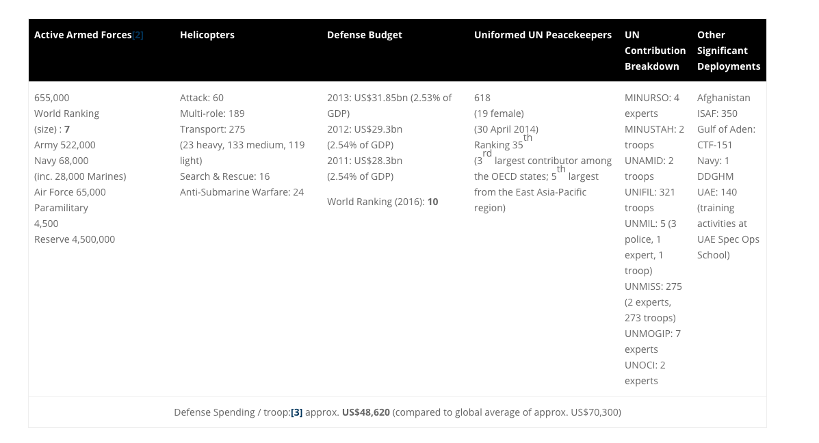

Figure 1.

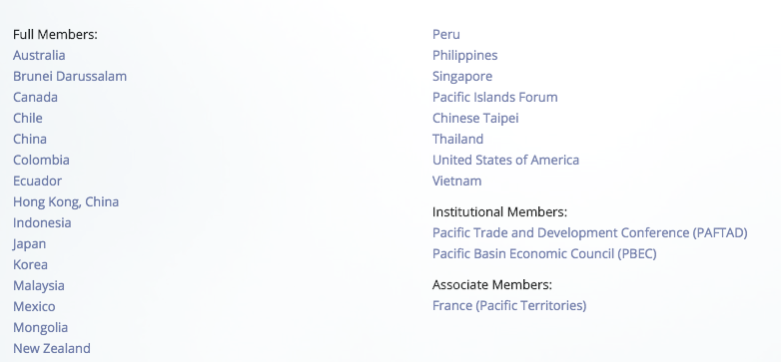

Figure 2.

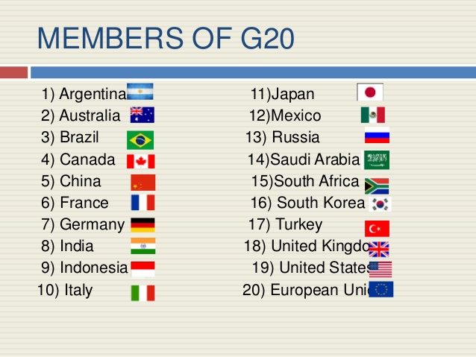

Figure 3.

<http://www.korea.net/Government/Constitution-and-Government/International-Relations>

<http://www.providingforpeacekeeping.org/2015/03/30/peacekeeping-contributor-profile-south-korea/>

<http://www.un-rok.org/category/news/>

<https://www.pecc.org/about/member-committees>

<http://www.country-data.com/cgi-bin/query/r-12362.html>

<http://international.gc.ca/trade-commerce/trade-agreements-accords-commerciaux/agr-acc/korea-coree/fta-ale/background-contexte.aspx?lang=eng>